Innovations in Science, Technology and Engineering (ISTE) Journal

Article Title - Final Submission Template for Papers Accepted for Publishing in Innovations in Science, Technology and Engineering (ISTE) Journal

Tolga DEPCİ ¹, Uğur DURAN ^{2,*}

¹ Department, Institute Name, City, Postal Code, Country, ORCID: XXXX-XXXX-XXXX-XXXX
² Department, Institute Name, City, Postal Code, Country, ORCID: XXXX-XXXX-XXXX-XXXX

Article Info  Research paper / Review paper  Keywords  Adsorption  Boron  Hydrometallurgy  Number Theory  Welding Technology | Abstract  Provide the abstract for the paper. The abstract should not exceed 200 words. The aim of the study, materials/methods, main results and major conclusions should be briefly expressed in the abstract. The abstract should not contain any equations, references, or footnotes. (Provide 4-6 keywords with the paper. The keywords should be in alphabetical order.)

1. Introduction

In this section, state the purpose of the study and describe why it matters. Avoid an extensive literature review; just summarize background information only for specific aspect of the topic being addressed.
The manuscript should be divided into clearly defined and numbered sections with brief headings. Subsections can also be used. Sections and subsections should be numbered 1.1. (then 1.1.1., 1.1.2., ...), 1.2., etc. Each section or subsection heading should appear on its own separate line.
The citations should be numbered consecutively in square brackets [1]. The sentence punctuation should be put after the brackets [2]. Refer multiple references [1], [2], [3] as [1-3]. In sentences, please use only reference number, as in [4]. Do not use ‘Ref. [4]’ except at the beginning of a sentence.

2. Materials and Methods
Tel.: +90 (326) 613 5600/2754

In this section, describe in detail what was done to answer the question(s) posed in the introduction. It should include sufficient details and references to permit full evaluation of your work or to repeat the experiments exactly as you have done them.
Tables should have consecutive numbers and headings located above the table in accordance with their appearance in the text.
Figures should have consecutive numbers and captions located below the figure in accordance with their appearance in the text. Captions should be justified left and ride sides of the figure or table. Locate the tables and figures close to the paragraph in which they are mentioned first. If one column is not wide enough for a table or figure, you can merge the columns as shown in the next page.
Each figure and table used in the article should be mentioned in the text and shown in the form of Figure 1 and Table 2. Letters in the figure should be large enough to be readily.
Abbreviations should be defined where they first appear in the text. The title of the paper should not have any abbreviation.
Equations should be fully justified for both sides. They should have consecutive equation numbers in parentheses aligned with the right margin as seen in Eq. (1). Following the equation, the meanings of the symbols in each equation should be immediately explained as below:
(1)
where are the Bernoulli polynomials of order
In addition, each equation used in the article should be indicated at least once in the text together with its equation number in the form of Eq. (1).
The authors should use only SI units throughout the paper.

Table 1. XXXXXXXX.
ZZZ | YYY | WWW | TTT
AAA | FFF | - 100 °C | ± 1.0 °C
BBB | GGG | 200 bar | 2.0 bar
CCC | HHH | 300 m | ± 3.0 %
DDD | KKK | 400 kg | ± 4.0 %
EEE | LLL | 500 rpm | ± 5.1 %

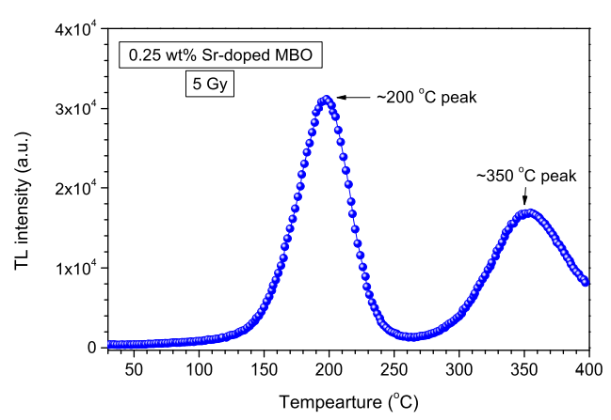
Figure 1. TL glow curve of 0.25 wt% strontium doped MBO, obtained with 1 °C/sheating rate after 5 Gy of beta dose..

Table 2. XXXXXXX.
AAA (cm) | 1
BBB (lb) | 2
CCC | 3
DDD (cc) | 4
EEE (kg) | 5
FFF | 6

3. Results and Discussion

Describe the findings along with interpretation of significant data. Tables and figures can widely be used in this section. Please prepare them in accordance with the formats described above.
The amount of padding and margin values should be as shown in the template.

4. Conclusions

In this section, state the main conclusions of the study.
Main results of the paper and its contribution can be reviewed. However, avoid duplicating the abstract. The importance of the work and future studies can be emphasized towards the end of this section.

Declaration of Ethical Standards

If the study does not require an Ethics Approval, the following declaration can be used:
“The author(s) of this article declare that the materials and methods used in this study do not require ethical committee permission and/or legal-special permission.”
Otherwise, please declare the board name granting ethics approval, approval date and approval number.

Conflict of Interest

All conflicts of interest should be declared. If there is not any conflict of interest, the content of this section can be arranged as follows.
“The authors declare that they have no known competing financial interests or personal relationships that could have appeared to influence the work reported in this paper.”

Funding

Please provide all the details requested by your funding and support organizations under the heading Funding as follows:
“This study is supported by Iskenderun Technical University Scientific Research Projects Coordination Unit. Project Number: 2021-01-01-001.”
If no support was received, then, under this heading "The author (s) has no received any financial support for the research, authorship or publication of this study." statement should be written.

Acknowledgements

Acknowledgements should be expressed in a separate section before the references.

References

A reference list at the end of the text with full details of all cited references is required in accord with the following examples. Also, all references must be clickable. These references should include a link that directs the reader to the contents of the reference when clicking on it as shown in [1]. (Subtitles shown with ‘*’ below are for informational purposes only. Do not use these titles in your article, write your references consecutively without any categorization.)

*Reference to a journal publication:

[1] Duran U., Acikgoz M., Araci S., 2020. A study on some new results arising from (p,q)-calculus, TWMS Journal of Pure and Applied Mathematics, 11(1), pp. 57-71.
[2] Nur N., Evis D., Bahçeci E., Depci T., Yildirim R. G., Kafadar V. E. 2019. Thermoluminescence properties of strontium doped magnesium tetraborate, Applied Radiation and Isotopes, 146, pp. 5-9.

*Reference to conference proceedings:

[3] Duran U., Acikgoz M., 2021. Gould-Hopper Based Degenerate Truncated Euler Polynomials. II. International Conference on Innovative Engineering Applications, Muş, Turkey, 20-22 May, Paper ID: 93.

*Reference to a book:

[4] Moran M. J., Shapiro H. N. Fundamentals of Engineering Thermodynamics, 5th ed., John Wiley and Sons, West Sussex, England, 2006.

Appendices

If there is more than one appendix, they should be entitled as A, B, etc. Equations in appendices should have separate numbers: Eq. (A.1), Eq. (A.2), etc. Tables and figures in appendices should be numbered as Table A.1 and Figure A.1, etc., respectively.

*Note to authors: Line spacing, paragraph spacing, font size, indents, and all other spelling features in the manuscript must be as shown in this template. After writing the article, please check all the spelling rules on the page named Author Guidelines of the journal web address. (Click to access the page).

Corresponding Author: iste.journal@iste.edu.tr

